EMBARGOED UNTIL 4PM GMT / 5PM CET:
January 12, 2018

JACK WHITE SET TO RELEASE
BOARDING HOUSE REACH
ON MARCH 23
VIA THIRD MAN RECORDS/XL RECORDINGS

GRAMMY® AWARD-WINNING ICON'S VISIONARY THIRD SOLO ALBUM
FEATURING NEW SINGLE "CONNECTED BY LOVE"

LIMITED EDITION VINYL LP AVAILABLE EXCLUSIVELY AS PART OF
THIRD MAN RECORDS VAULT PACKAGE #35 (HYPERLINK)
SUBSCRIPTIONS OPEN NOW THROUGH JANUARY 31

BOARDING HOUSE REACH Standard Cover – High Res HERE
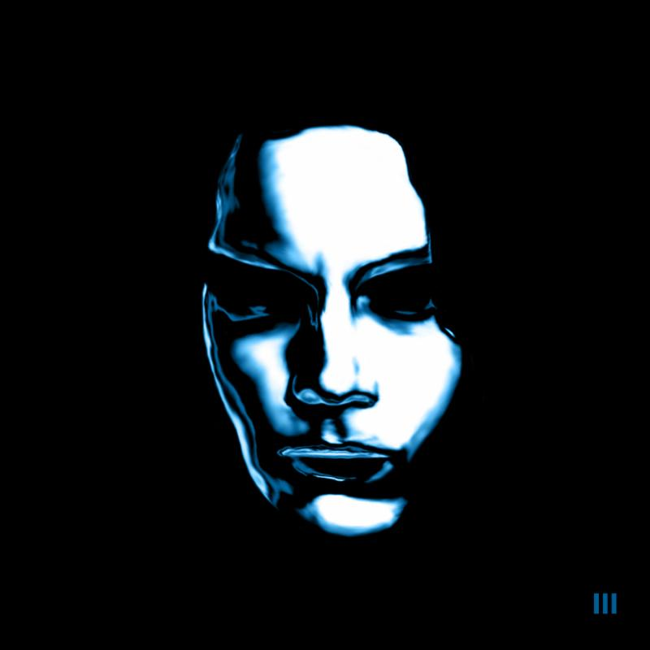
BOARDING HOUSE REACH Limited Edition Vault LP Cover – High Res HERE

Jack White has announced the release of his eagerly anticipated new album, BOARDING HOUSE REACH (Third Man/XL Recordings). The 12-time GRAMMY® Award-winner's third solo LP and first all-new album in nearly four years, BOARDING HOUSE REACH will arrive everywhere on Friday, March 23.

BOARDING HOUSE REACH sees Jack White expanding his musical palate with perhaps his most ambitious work thus far, a collection of songs that are simultaneously timeless and modern. Written and conceived while holed up in a Spartan apartment with literally no outside world distractions, White exclusively used the same kind of gear he had when he was 15 years old (a quarter-inch four-track tape recorder, a simple mixer, and the most basic of instrumentation). The album explores a remarkable range of sonic terrain - crunching rock 'n' roll, electro and hard funk, proto punk, hip hop, gospel blues, and even country - all remapped and born anew to fit White's matchless vision and sense of restless experimentation. BOARDING HOUSE REACH is a testament to the breadth of Jack White's creative power and his bold artistic ambition.

BOARDING HOUSE REACH features White on vocals, acoustic and electric guitars and drums, organ, and synthesizers. He's backed by a remarkable new lineup of musicians that includes: drummer Louis Cato (Beyoncé, Q-Tip, John Legend, Mariah Carey), bassists Charlotte Kemp Muhl (The Ghost of a Saber Tooth Tiger) and NeonPhoenix (Kanye West, Lil Wayne, Jay-Z), synthesizer players DJ Harrison and Anthony "Brew" Brewster (Fishbone, The Untouchables), keyboardists Neal Evans (Soulive, Talib Kweli, John Scofield) and Quincy McCrary (Unknown Mortal Orchestra, Pitbull), percussionists Bobby Allende (David Byrne, Marc Anthony) and Justin Porée (Ozomatli), and backing vocalists Esther Rose and Ann & Regina McCrary of Nashville's beloved gospel trio, The McCrary Sisters, as well as longtime collaborators like drummers Daru Jones (Nas, Talib Kweli) and Carla Azar (Autolux, Depeche Mode, Doyle Bramhall II). Singer-songwriter C.W. Stoneking also appears, contributing a stirring spoken word performance to the album's "Abulia and Akrasia."

BOARDING HOUSE REACH was produced by Jack White III and recorded at Third Man Studio in Nashville, TN, Sear Sound in New York, NY, and Capitol Studios in Los Angeles, CA; the album was mixed by Bill Skibbe, Joshua V. Smith, and White at Third Man Studio in Nashville, TN.

BOARDING HOUSE REACH is heralded by the rapidly acclaimed new single, "Connected By Love," b/w "Respect Commander," which is available now digitally worldwide and as a physical 7-inch vinyl single pressed at Third Man Pressing in Detroit, MI. In addition, a limited edition tri-color 7-inch single will be on sale for one day only, Saturday, January 13th, exclusively at Third Man Records brick & mortar stores in Nashville and Detroit.

"Connected By Love" is accompanied by a brand-new music video from director Pasqual Gutierrez - watch it now HERE. The single was greeted with rapturous global applause upon its arrival on Wednesday, with Billboard declaring the song "a classic White confessional blues burner," and Entertainment Weekly calling it "a searing, organ-lined plea to a former flame." NPR's Bob Boilen wrote, "it's a blend of old guitar blues that is simultaneously on the edge of rock's horizon." "The four-year wait is over," says Rolling Stone Jack is back with the "blistering first single" from BOARDING HOUSE REACH.

Additionally, White & Third Man Records have revealed a special BOARDING HOUSE REACH-themed Vault Package #35 which will be the ONLY limited edition of the new album, with subscriptions open today through January 31. The new package is highlighted by a limited edition, colored vinyl version of BOARDING HOUSE REACH that will be the only vinyl variation of the LP to be made available. Pressed at Third Man Pressing in the Cass Corridor of Detroit, the 180-gram, blue and black swirl vinyl edition features exclusive Vault-only cover art which dramatically depicts White's stylized face and is printed on arresting holographic foil paper in the classic Stoughton tip-on style. The LP is further accompanied by a unique-to-this-package 12" x 24" insert featuring the complete album lyrics.

The BOARDING HOUSE REACH Vault package also includes a two-song demo 7-inch single, offering up embryonic versions of "Connected By Love" and the album track, "Why Walk a Dog?" The former take - billed here under its original title, "Infected By Love" - was recorded entirely by White in the aforementioned Nashville apartment. White found keyboard tones on this recording that the world's most seasoned session musicians could not recreate in the studio and thus, some of those tones were sourced from this simple demo to be utilized on the final album version. Meanwhile, "Why Walk a Dog?" was recorded, like much of the BOARDING HOUSE REACH demos, alone at his private songwriting refuge. With its expressive synth and drum machine cadence, the track is overtly hypnotic even in this early state. Indeed, the "Connected By Love" and "Why Walk a Dog?" single provides a fascinating insight into White's process, revealing the creative progression of his songs from inception to completion.

In addition to the recorded material, Vault Package #35 comes with three separate and exclusive photographs shot during BOARDING HOUSE REACH recording sessions. Taken by noted photographer -- and White's longtime friend -- David Swanson at Sear Sound in New York and Capitol Studios in Los Angeles, these large-format, high quality glossy reproductions are exclusive to the Vault. The photographs will be coupled with three foil-stamped poetry broadsides, printed on silky metallic papers (black, white, and blue) containing White's poems from the new album tracks, "Abulia and Akrasia," "Ezmerelda Steals the Show," and "Get in the Mind Shaft."

BOARDING HOUSE REACH Vault Package #35 will also include, for the third year running, a custom 2018 Third Man Records challenge coin, complete with album-specific artwork. The substantial and stylish coin doubles as a 45 adaptor and grants its holder 10% off purchases in both Third Man Records storefronts. Past Third Man Challenge coins will no longer be valid at Third Man storefronts once Vault Package #35 ships.

Third Man Vault subscriptions are open now through January 31. All BOARDING HOUSE REACH Vault packages will ship to arrive on and as close to the album's official March 23 street date. Learn more about this package, additional Vault benefits and subscribe now at Third Man Records HERE.

White will celebrate BOARDING HOUSE REACH with a number of just-announced headline festival performances, including Atlanta, GA's Shaky Knees Music Festival (May 4-6), Boston Calling (May 25-27), and the Governor's Ball Music Festival in New York (June 1-3). Additional dates will be unveiled soon and every online ticket purchased for North American headline shows will include a physical copy of BOARDING HOUSE REACH on CD with the option to upgrade to the standard black vinyl single LP. For updates and tickets, please visit jackwhiteiii.com/tour-dates.

BOARDING HOUSE REACH TRACK LIST
1. Connected By Love
2. Why Walk A Dog?
3. Corporation
4. Abulia and Akrasia
5. Hypermisophoniac
6. Ice Station Zebra
7. Over and Over and Over
8. Everything You've Ever Learned
9. Respect Commander
10. Ezmerelda Steals The Show
11. Get In The Mind Shaft
12. What's Done Is Done
13. Humoresque

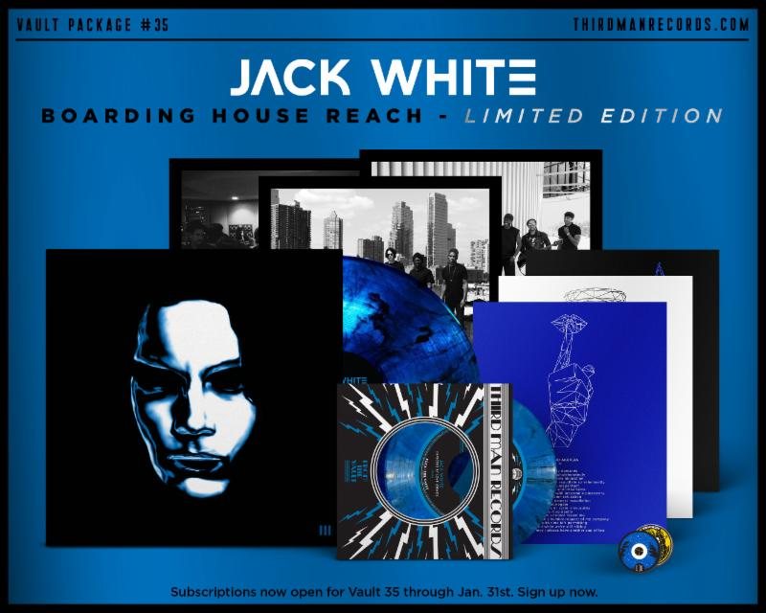

JackWhiteIII.com

ThirdManRecords.com

For more information, please contact:

Jon Wilkinson
jon@technique-pr.com

